Rosanna Cubs – Swimming night
LaTrobe Uni Swimming Pool
Tuesday 3rd September, 6:20pm-8pm

On Tuesday 3rd Sep, we’ll be going swimming at the LaTrobe Uni Pool. Cubs will have the opportunity to go for the Level 1 or Level 2 Swimming Badge. Cubs should look at the Swimmer Badge in their yellow book before the night to choose which level they’d like to try for. They can also look at http://www.rosannacubs.org/badge/badgeSwimmer.htm
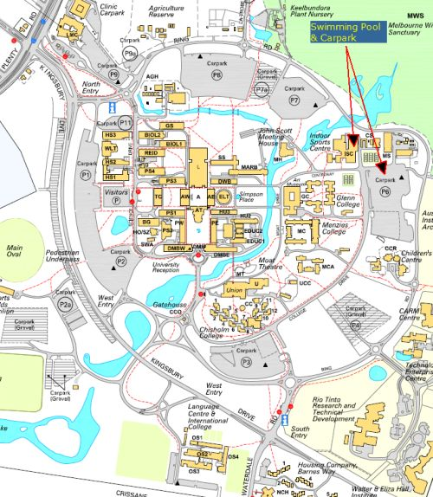
- Time: 6:20-8pm – Note different time to
normal Cubs
- Cost: Free this time!
- Location: Latrobe Uni Swimming Pool –
https://goo.gl/maps/vBrNU8MtYLq
Bring: Togs, Towel, warm clothes to go
home in
- Note: Cubs going for Level 2 Badge need
shorts and shirt, in addition to their
togs, to swim in and remove in the
water
Please be on time... we need the Cubs in the water by 6:30pm

Don’t miss out

Regards
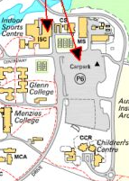
The Leaders
Rosanna Cub Scouts

See us at http://www.rosannacubs.org

